Add the configuration file to github

- Create Repository
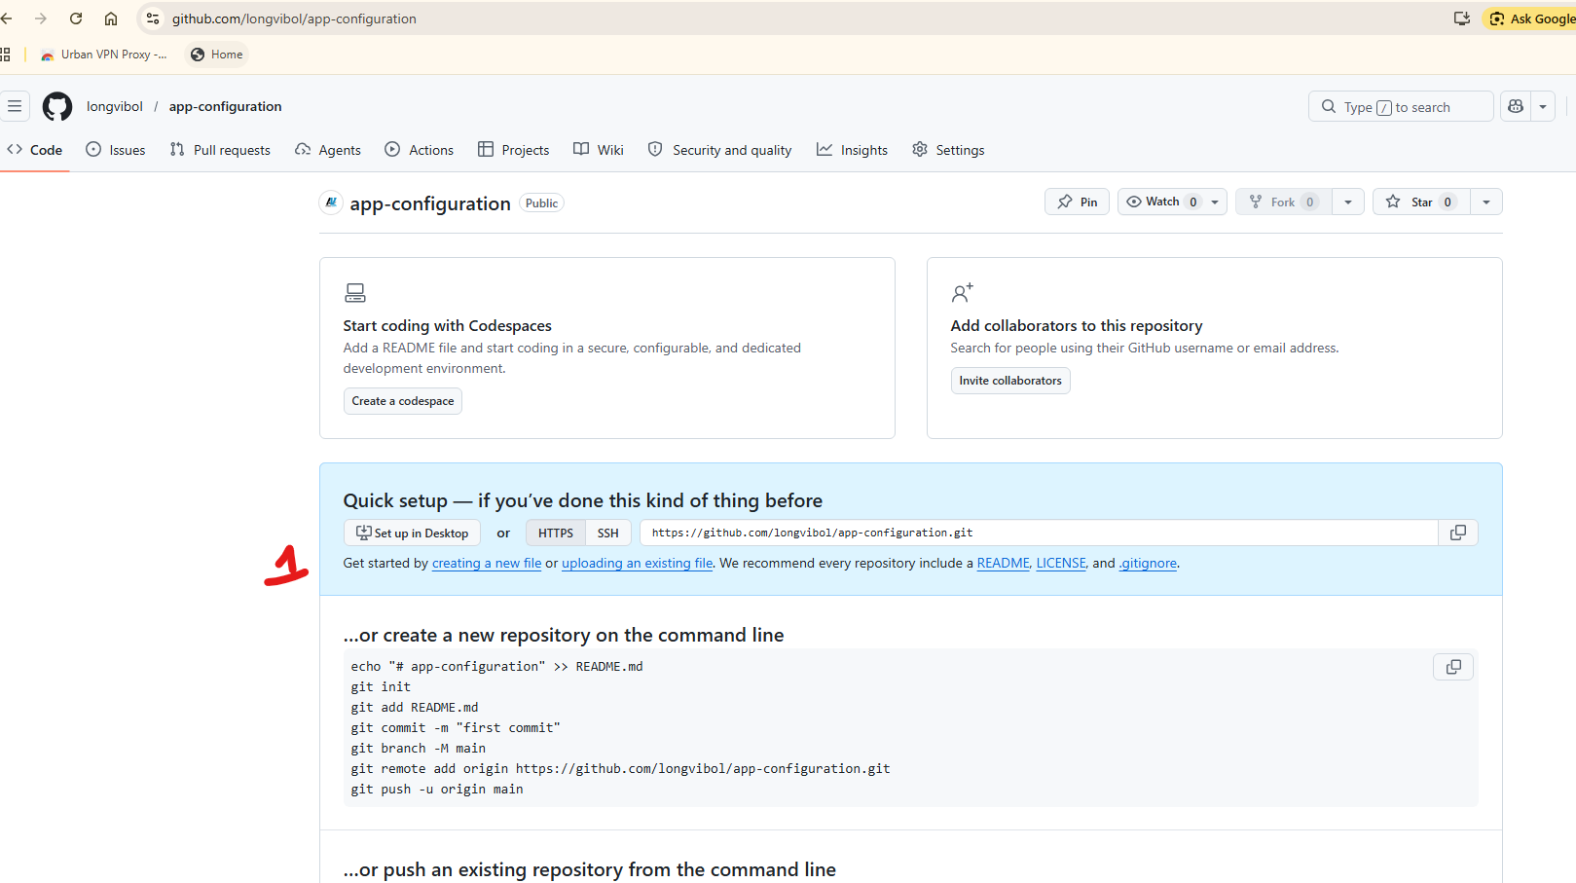
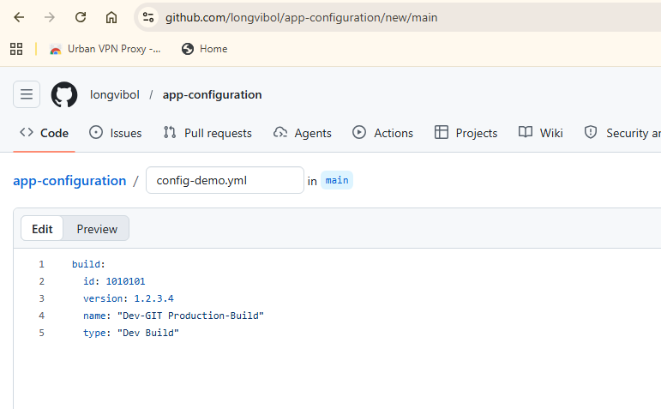

- We can create many file to have configuration: dev, prod, defaul
- Map from the git hub to the Spring boot: config server
- Add : @EnableConfigServer

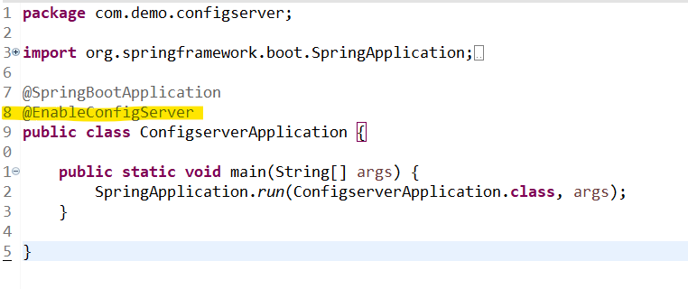

- Access to url : http://localhost:8888/configdemo/default
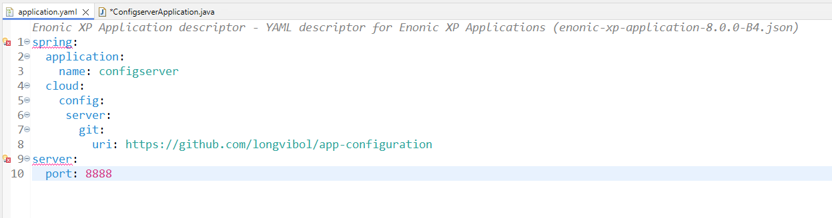

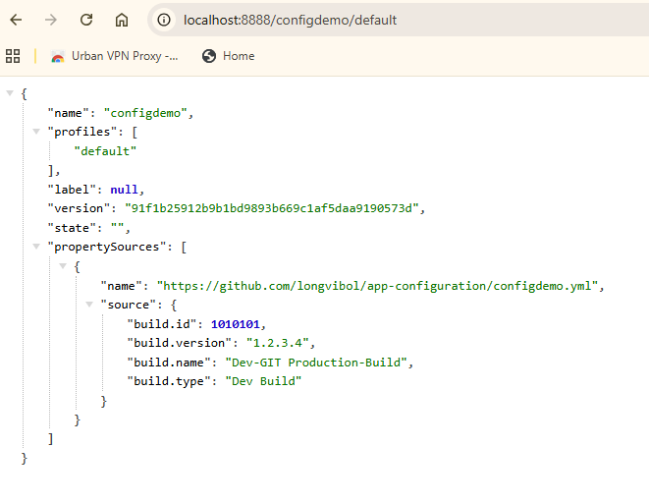

If we check the log:

2026-05-28T15:33:51.391+07:00 INFO 16924 --- [configserver] [nio-8888-exec-1] o.s.c.c.s.e.NativeEnvironmentRepository : Adding property source: Config resource 'file [C:\Users\home\AppData\Local\Temp\config-repo-3943239808996779000\configdemo.yml]' via location 'file:/C:/Users/home/AppData/Local/Temp/config-repo-3943239808996779000/'

- វាធ្វើការ store the file int the AppData and fetch the configuration from the github

- Create other configurations
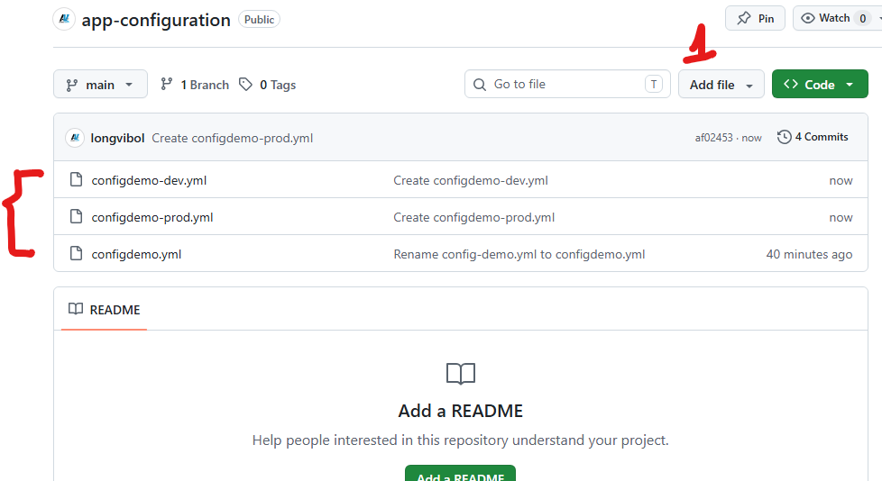

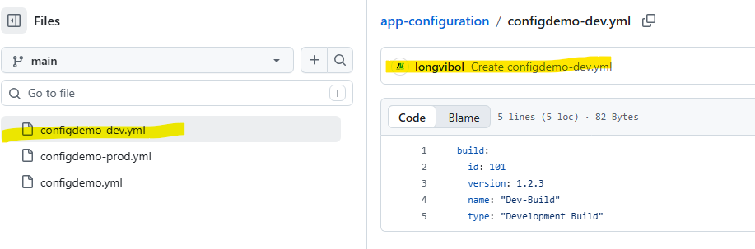

- http://localhost:8888/configdemo/dev
- http://localhost:8888/configdemo/prod
- http://localhost:8888/configdemo/default

